Project: Inventory Management System.
Week: 1
Prepared by: Ankush Kumar
Role: Assisting interns in development (Frontend).
Objective of the Week
To ensure that the interns learn the fundamentals of HTML so that they can independently design and create the layout of web pages required for the Inventory Management System project.
Activities Performed
Explained the overall architecture and modules of the Inventory Management System to the interns.
Guided interns in creating the basic HTML pages.
Reviewed the work completed by interns and provided corrections where necessary.
Ensured a consistent structure is maintained across all pages.

Technologies Used

HTML

Challenges Faced
- Helping interns understand the overall workflow of the system.
- Standardizing page structures among multiple contributors.

Outcome
Successfully established the basic frontend structure and provided guidance to interns for further development.

HOME PAGE
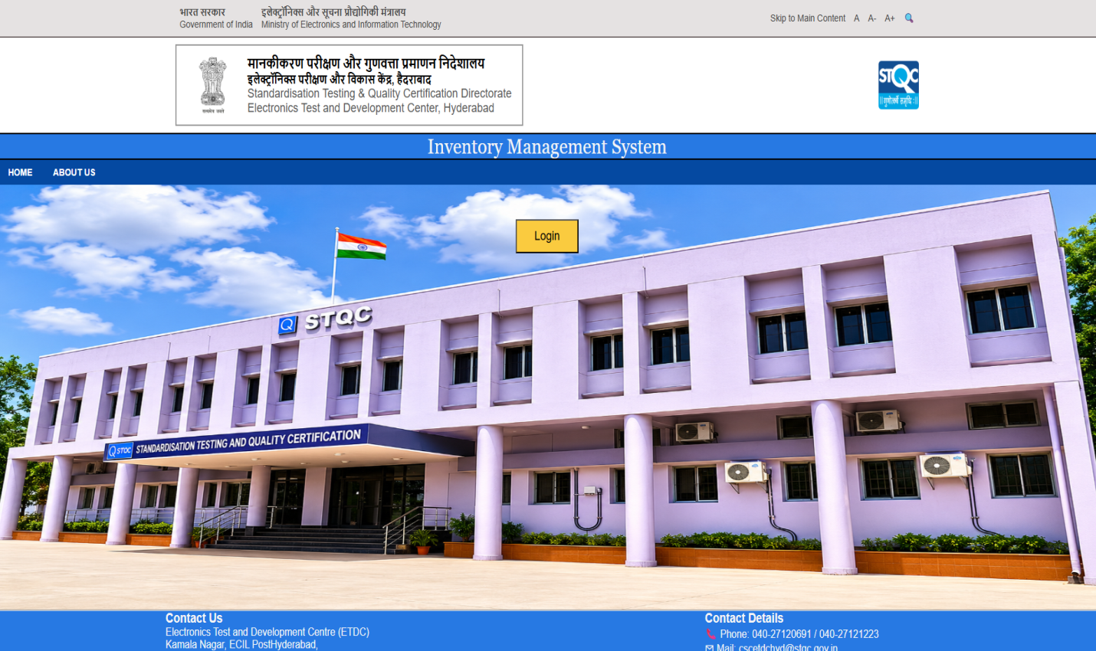

ABOUT PAGE
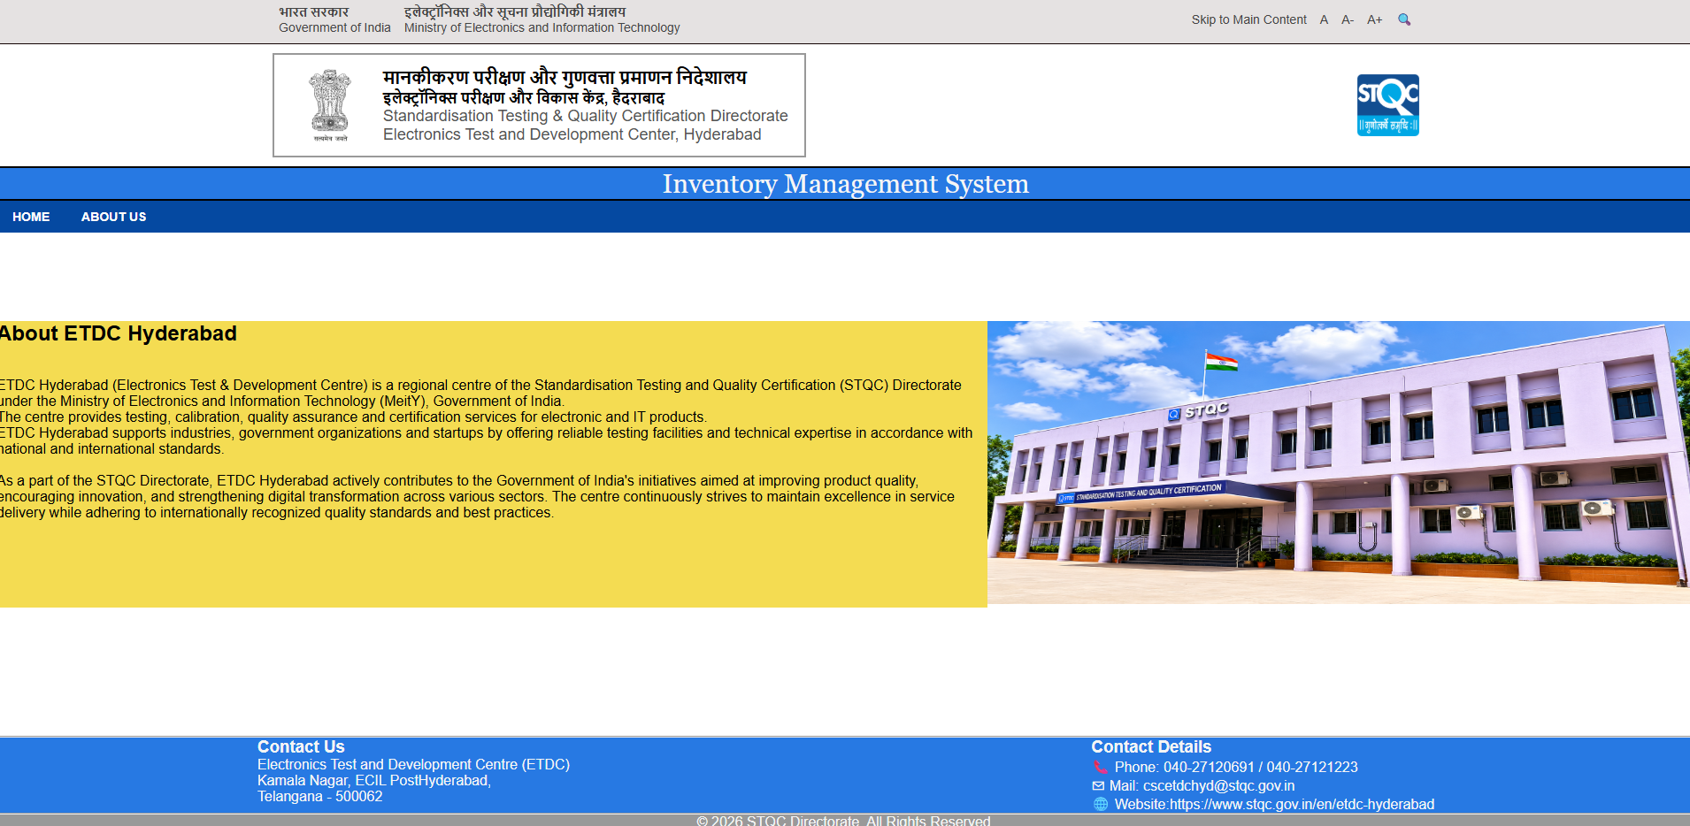
Dashboard for Admin
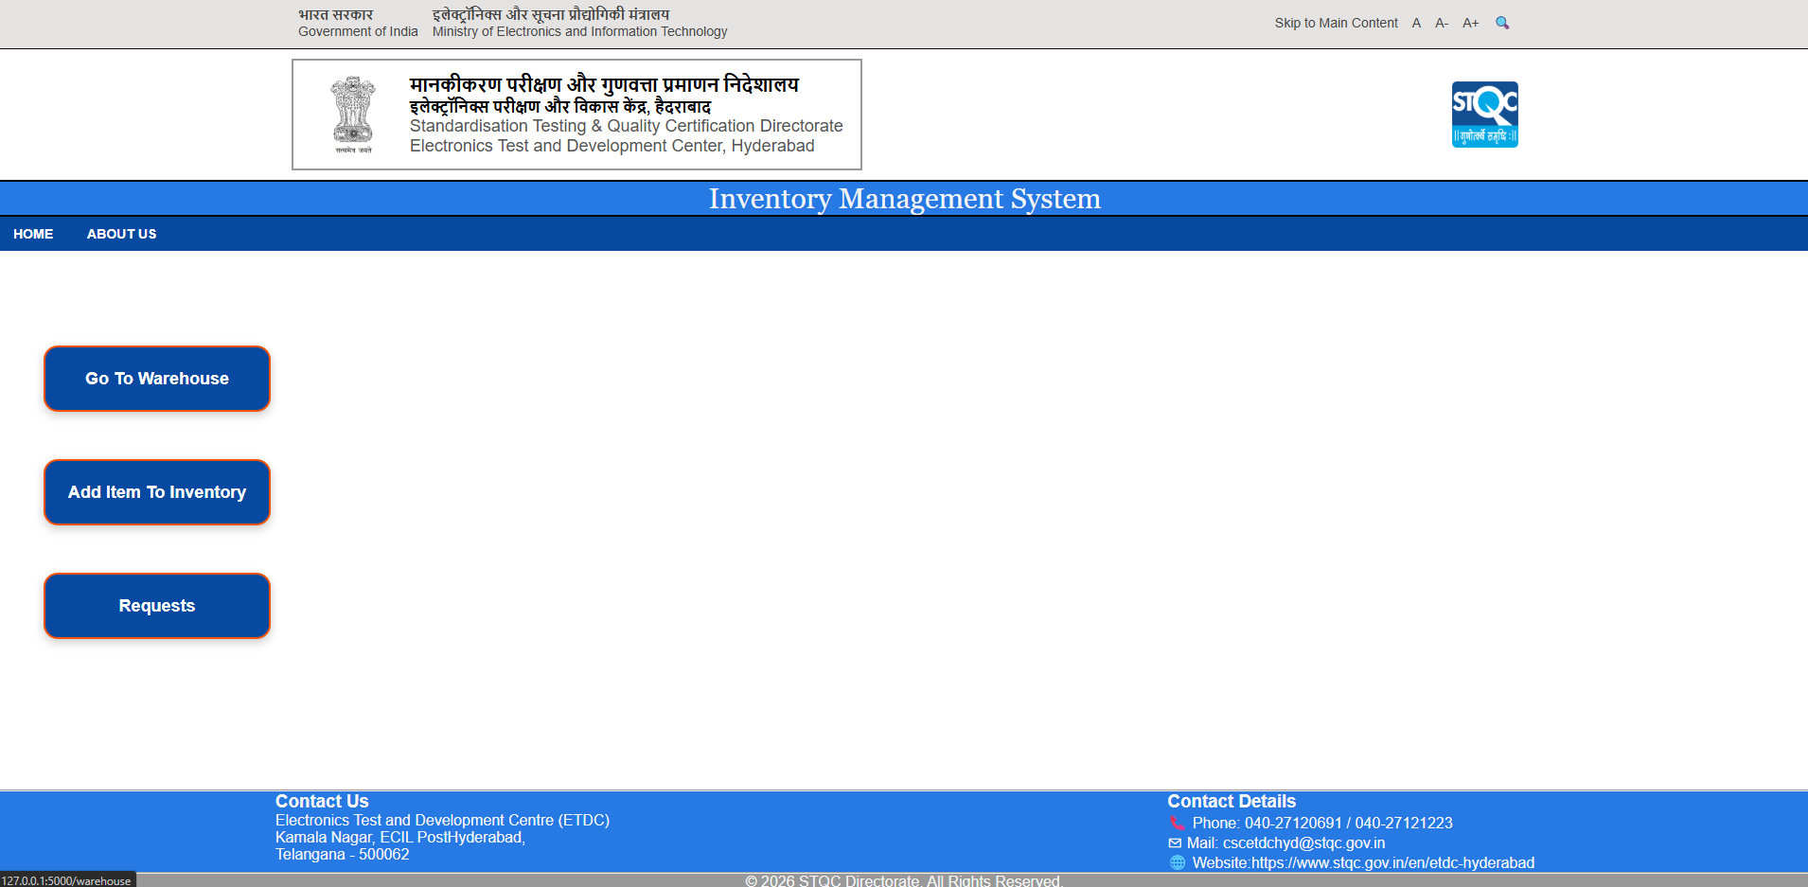
Dashboard for Staff
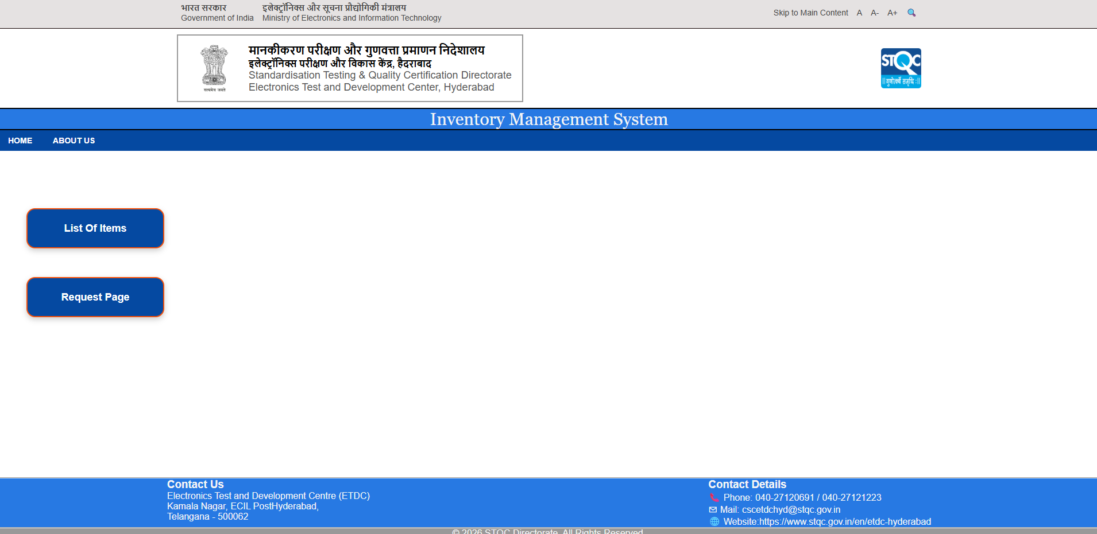
Dashboard for Dept. Head

